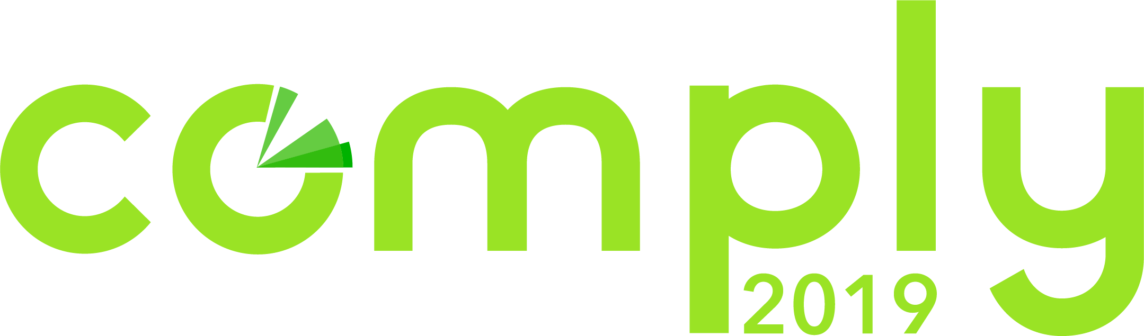

COMPLY2019 Attendance Justification Letter

<Date>

Dear <Name>,

I would like to attend COMPLY2019, The RegTech and Compliance Conference, on May 14-15, 2019 at Tribeca 360 in New York City. For the last five years the COMPLY Conference has united the industry and served as a catalyst for the advancement of the Compliance, Risk and RegTech ecosystem. COMPLY brings together the most comprehensive gathering of regulators, compliance and risk professionals, sales and marketing leaders, innovators, investors and legal experts from across the globe.

3 Reasons I Need to Attend COMPLY2019

1. Actionable Takeaways from Inspirational Speakers and Leaders
The goal of COMPLY each year is to bring industry pioneers together to share their expertise with all of us and transform the way companies focus on compliance. The innovative speakers that participate in COMPLY each year have all influenced the development of the industry, and this year I will have the opportunity to learn from Richard Cordray, founding director of the CFPB, and senior leadership from the FTC, Lyft, FINRA, PayPal, OnDeck, LendUp and many more with several State AGs also participating.

2. Navigate the Regulatory Landscape
As the regulatory revolution continues to unfold, consumers and companies find themselves asking how to stay up-to-date with the evolving regulations. Regulators from the FTC, FINRA, CFPB, State AGs and more will be at COMPLY2019 to share the key developments to navigating the current regulatory landscape. I will be able to inform our company on the latest technology trends, positive interactions between consumers and companies and how to execute business practices in a safe way.

3. COMPLY2019’s Focus on Industry Collaboration
The theme of this year’s conference incorporates everyone and the idea that compliance is not an individual endeavor or even just one department’s responsibility anymore. Organizations that understand this idea are building and nurturing a culture of compliance as a company-wide responsibility and thriving because of their collaborative efforts. During the conference, I will learn how to harness this idea to COMPLY Together, and embrace the theory that none of us is as smart as all of us.

Registration for the conference is $1,895 if I register before April 30th. If 3 or more employees from our company attend, we each receive 30% off our registrations.

By attending COMPLY2019, I’ll undoubtedly gain insights and key developments on a variety of relevant topics during the tactical presentations, panel discussions, workshops, keynotes and breakout sessions to ensure our company is utilizing essential resources to navigate the ever-changing regulatory landscape.

Regards,

<Signature>

